/*
* Chris Tjon - Wed 4pm - Ex 8.3 - Milky Way Program
*/
package milkyway;

import java.awt.*;
import java.applet.Applet;

public class MilkyWay extends Applet
{
private Scrollbar lengthBar, heightBar;
private int height = 100, length = 100;

public void paint(Graphics g)
{
int xpos;
int ypos;
int diameter;

for (int i = 0; i < 100; i++)
{
xpos = (int)((Math.random() * 200) + 1);
ypos = (int)((Math.random() * 200) + 1);
diameter = (int)((Math.random() * 100) + 1);
g.drawOval(xpos, ypos, diameter, diameter);
}
}
}
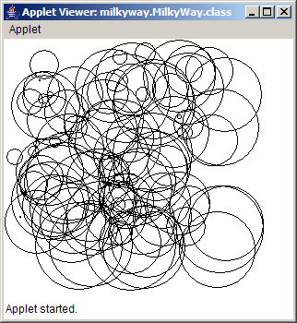
/*
* Chris Tjon - Wed 4pm - Ex 8.8 - Multiplication Table
*/
package multiplication;

import java.awt.*;
import java.applet.*;

public class TimesTable extends Applet
{
private int size = 12;

public void paint (Graphics g)
{
for (int i = 1; i <= size; i++)
{
for (int j = 1; j <= size; j++)
{
int result = i * j;
g.drawString("" + (i * j), i * 25, j * 25);
}
}
}
}

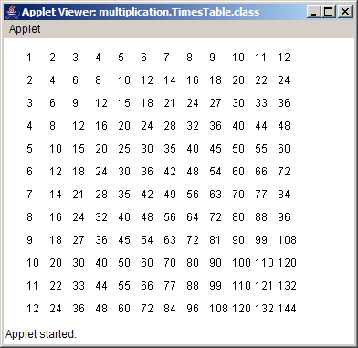

/*
* Chris Tjon - Wed 4pm - Ex 7.8 - Calculator Program
*/
package calculator;

import java.applet.*;
import java.awt.*;
import java.awt.event.*;

public class Calculator extends Applet implements ActionListener
{
private Button one, two, three, four, five, six, seven,
eight, nine, zero, plus, minus, equals, clear;
private int input;
private int total;

public void init()
{
one = new Button("1");
add (one);
one.addActionListener(this);

two = new Button("2");
add (two);
two.addActionListener(this);

three = new Button ("3");
add (three);
three.addActionListener(this);

four = new Button ("4");
add (four);
four.addActionListener(this);

five = new Button ("5");
add (five);
five.addActionListener(this);

six = new Button ("6");
add (six);
six.addActionListener(this);

seven = new Button ("7");
add (seven);
seven.addActionListener(this);

eight = new Button ("8");
add (eight);
eight.addActionListener(this);

nine = new Button ("9");
add (nine);
nine.addActionListener(this);

zero = new Button ("0");
add (zero);
zero.addActionListener(this);

plus = new Button ("+");
add (plus);
plus.addActionListener(this);

minus = new Button ("-");
add (minus);
minus.addActionListener(this);

equals = new Button ("=");
add (equals);
equals.addActionListener(this);

clear = new Button ("Clear");
add (clear);
clear.addActionListener(this);
}

public void paint(Graphics g)
{
g.drawString ("Input = " + input, 50,130);
g.drawString ("Total = " + total, 50,150);
}

public void actionPerformed(ActionEvent event) {
if (event.getSource() == one)
input = (input * 10) + 1;

if (event.getSource() == two)
input = (input * 10) + 2;

if (event.getSource() == three)
input = (input * 10) + 3;

if (event.getSource() == four)
input = (input * 10) + 4;

if (event.getSource() == five)
input = (input * 10) + 5;

if (event.getSource() == six)
input = (input * 10) + 6;

if (event.getSource() == seven)
input = (input * 10) + 7;

if (event.getSource() == eight)
input = (input * 10) + 8;

if (event.getSource() == nine)
input = (input * 10) + 9;

if (event.getSource() == zero)
input = (input * 10) + 0;

if (event.getSource() == plus)
{
total += input;
input = 0;
}

if (event.getSource() == minus)
{
total -= input;
input = 0;
}

if (event.getSource() == equals)
input = total;

if (event.getSource() == clear)
{
input = 0;
total = 0;
}

repaint();
}
}
